Indrawan Saputra

CPSC 473

Assignment 8

4/27/16

1. Post new reminder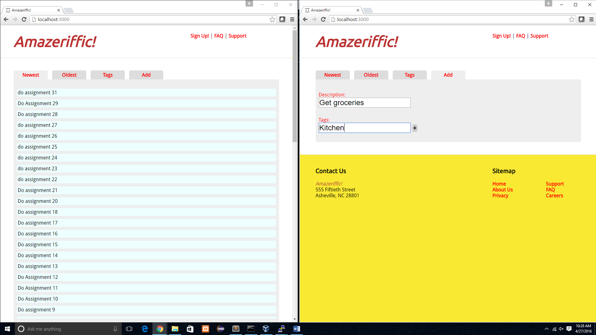

2. Alert user that a new reminder is posted.

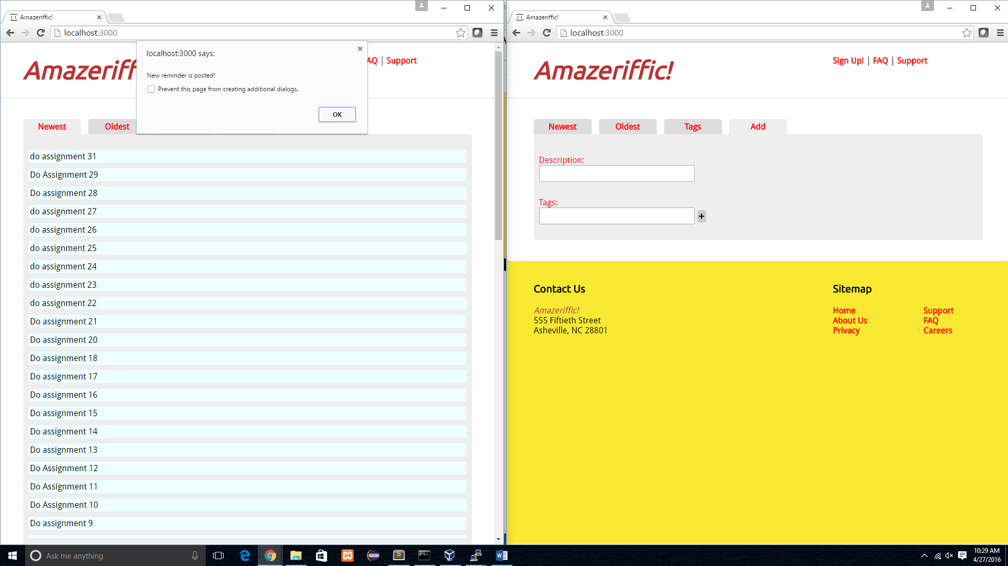

3. The new reminder is posted without refreshing the page.

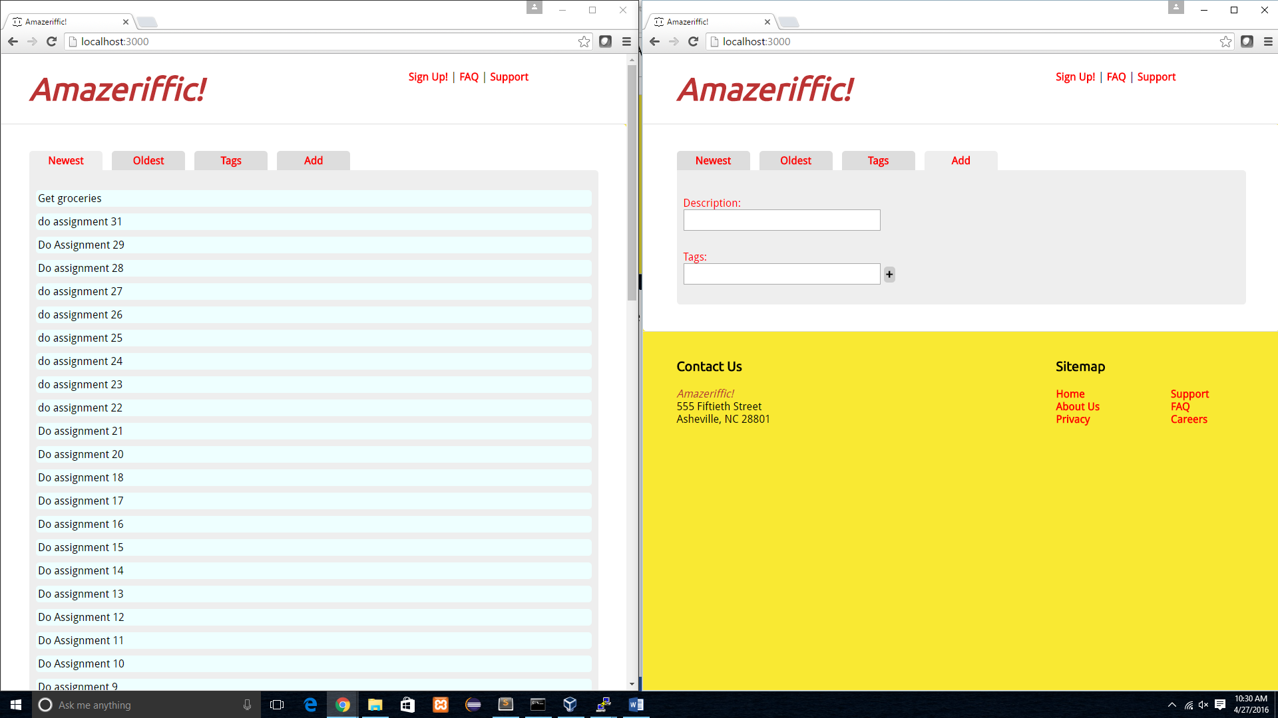

4. Post a new reminder on the oldest tab

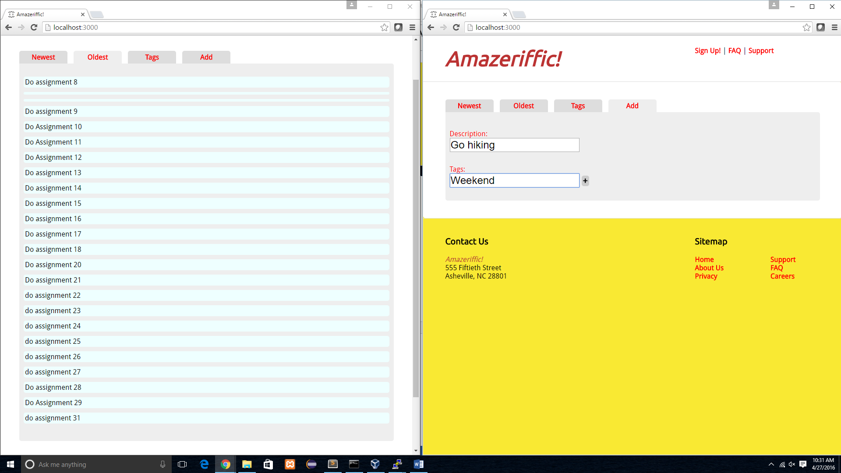

5. Alert user that a new reminder is posted.

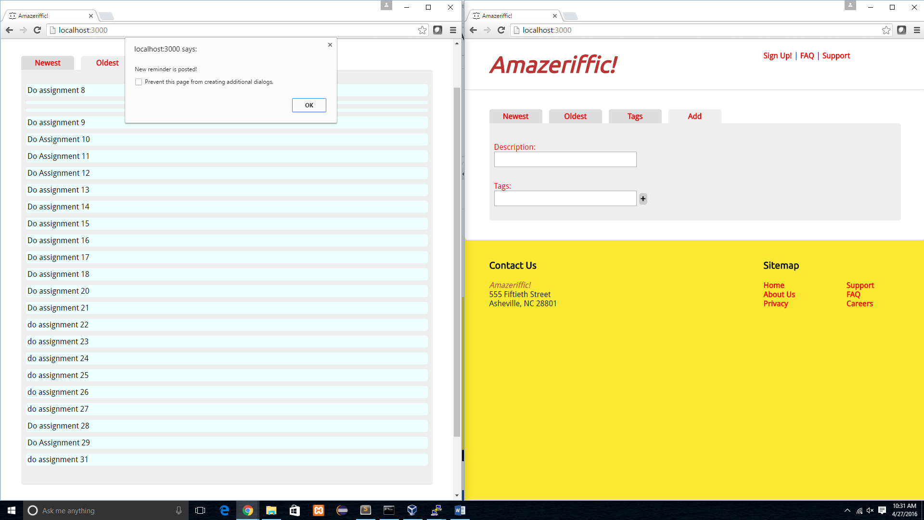

6. A new reminder is posted on the ‘Oldest’ tab.

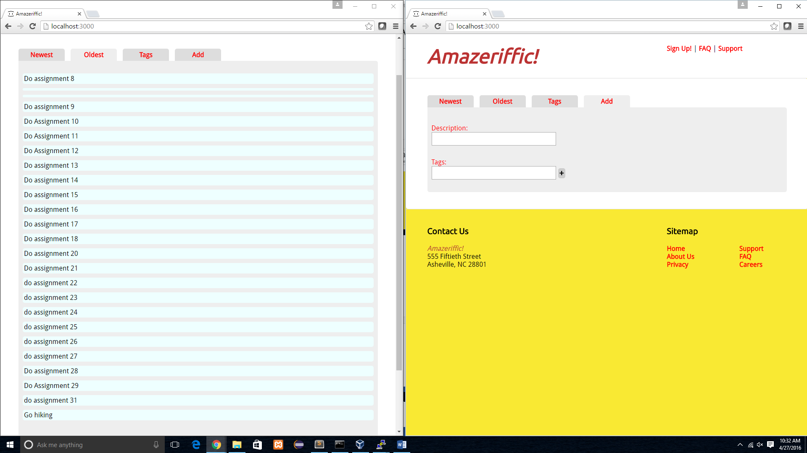

7. Post a new reminder on the ‘Tags’ tab

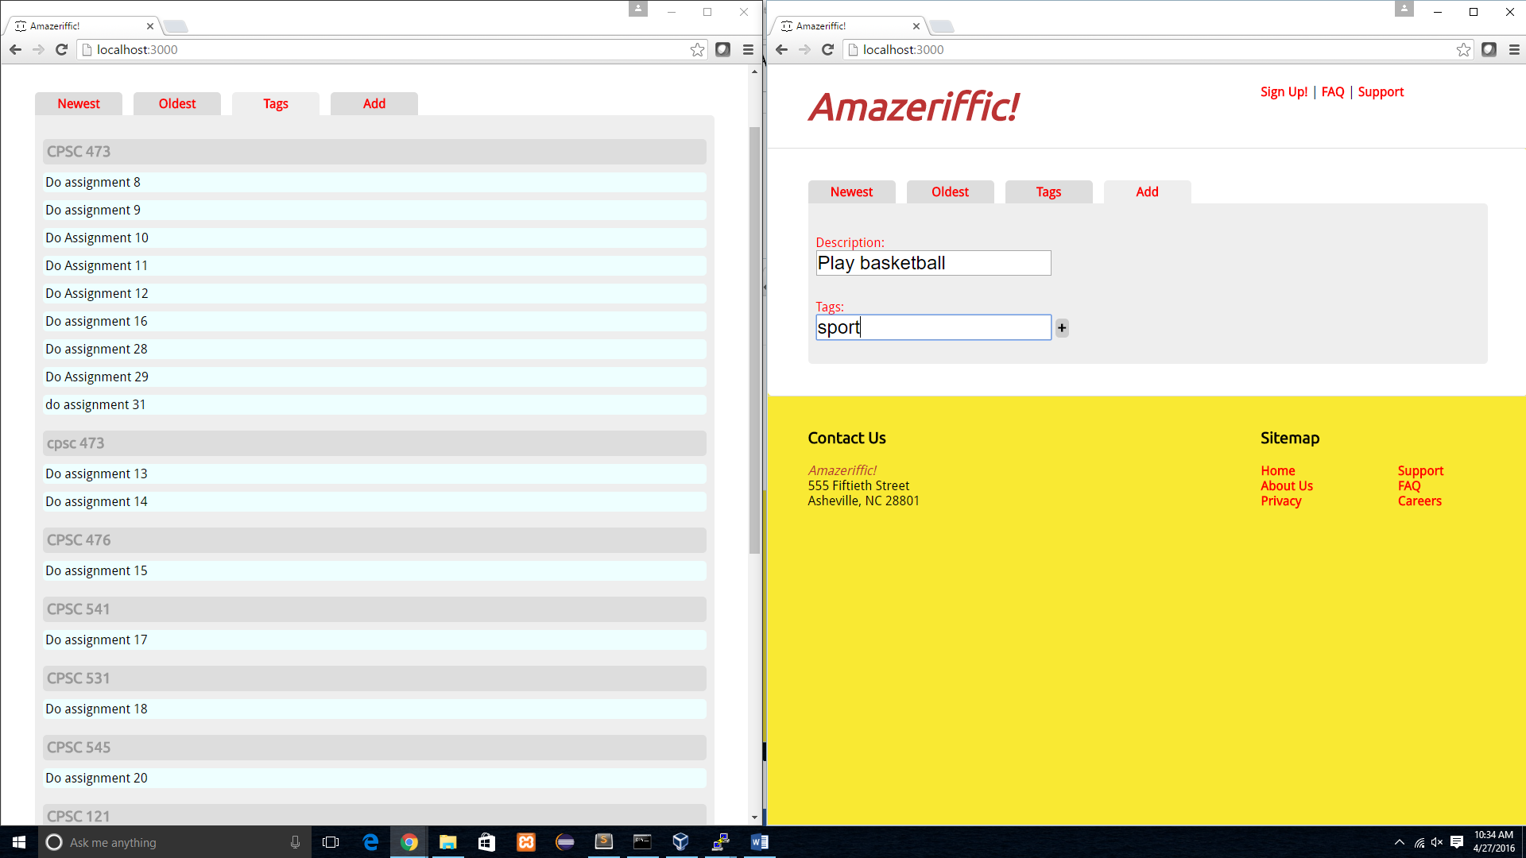

8. Alerting user that a new reminder is posted.

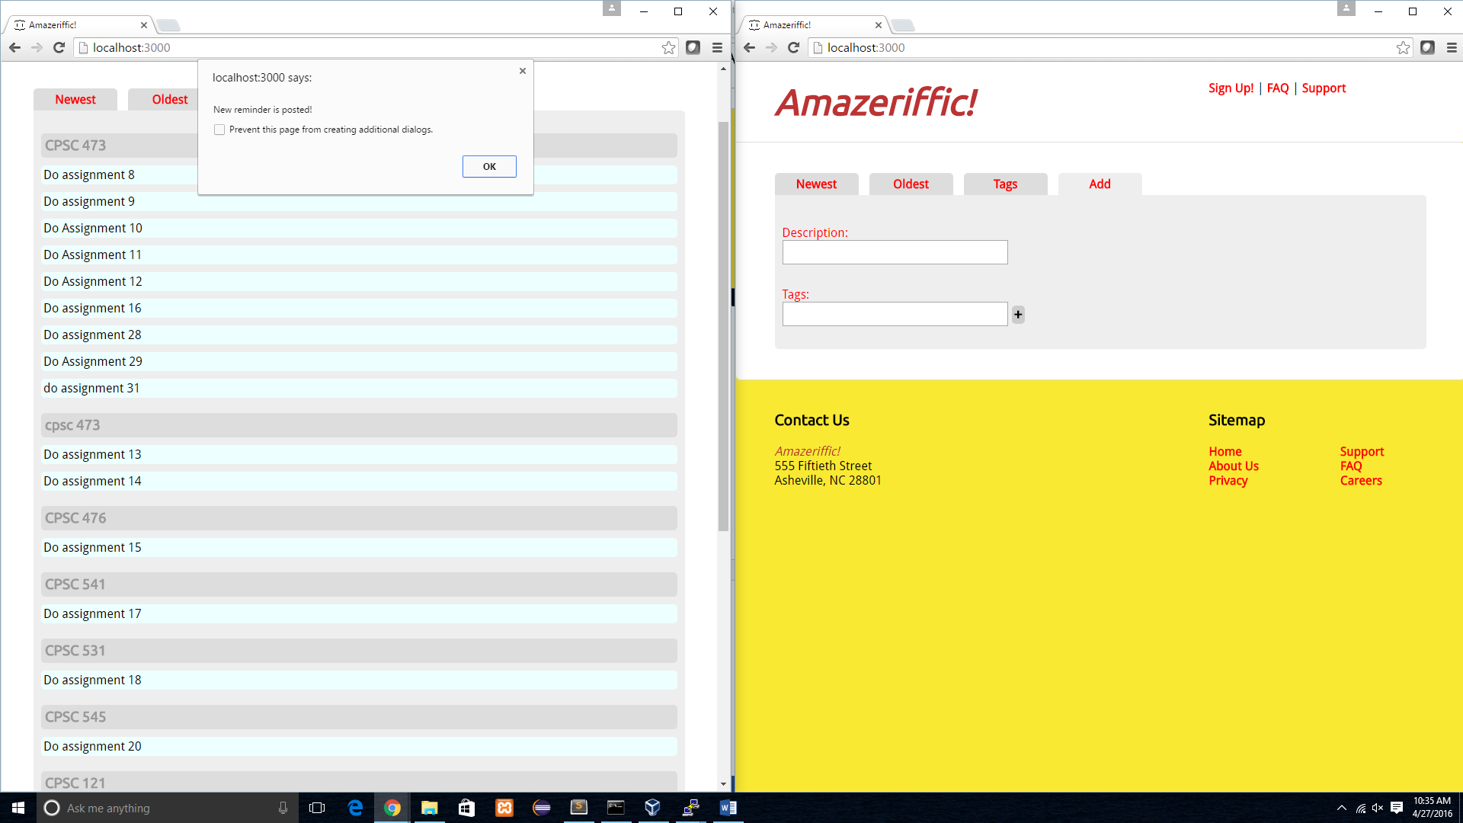

9. A new reminder is posted on the ‘Tags’ tab.

